Complex computer based simulator

of 200 megawatt unit with TP-100A pulverized coal steam generator and
K-200-130 turbine

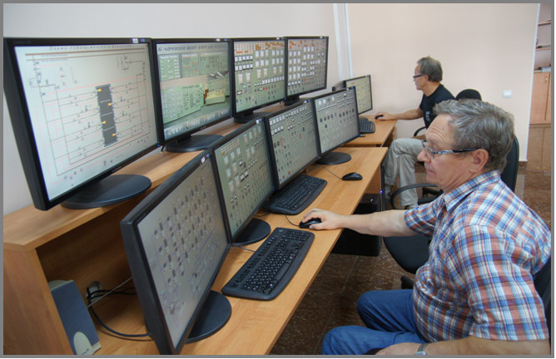

The simulator is designed for 200 megawatt unit shift operating personnel training. The simulator ensures the qualification maintaining on due level of unit shift personnel, its preparedness for highly efficient and accident-free unit operation. This may be achieved on the regular training basis.
The simulator ensues the following shift personnel training: Boiler and Turbine department shift supervisor; Electrical department shift supervisor; senior control room (MCR) unit operator; MCR unit operator, senior on duty electrician; turbine field operator; boiler field operator. Besides, it’s possible to train Instrumentation and Control department operating personnel on the simulator, as well as managing personnel. The simulator can be used also for shift personnel training of the similar units with the same type of technological equipment.
The following main tasks may be achieved during personnel training with the simulator:
- - New specialists learning and training with purpose of using the staff as shift operating personnel of 200 megawatt units;
- - Other power plant specialists retraining and other profile personnel relearning for specified job;
- - Regular learning and training of unit shift personnel;
- - Individual and team training in emergency and abnormal unit modes of operation;
During personnel training on the simulator, the following tasks are pursued:
- - identification of specific technological situations;
- - interface with control subsystems (instrumentation, regulators, interlocks, protections, alarms);
- - monitoring and control of technological equipment during unit start-up, normal, abnormal and emergency modes of operation.

Unit Plant Model is installed in the following hardware:
- 10 personal computers, one of which (for instructor station) is more advanced in calculation capacity;
- 24 monitors;
- Laser printer.
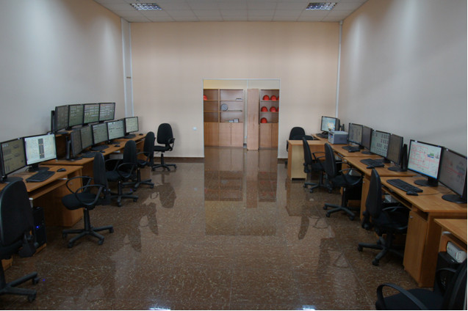
The simulator is developed for unit shift personnel learning and training. The simulator provides the following work places:
- Instructor station;
- Power plant shift supervisor work place;
- Boiler and turbine department shift supervisor work place;
- Unit control room operator work place;
- Unit control room senior operator work place;
- Turbine equipment field operator work place;
- Boiler equipment field operator work place;
- Senior on duty electrician work place;
- On duty I&C department electrical fitter work place.
As example, the work place of unit control room operator is presented in the following picture:
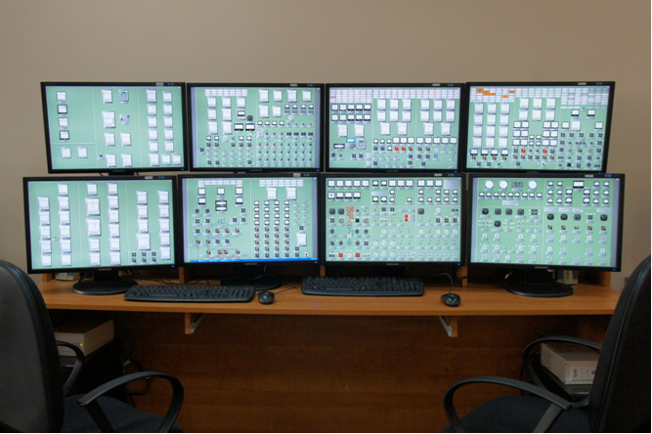
Before commissioning, the simulator was tested at the Moldavia Fossil Fuel Power Plant ground in the following unit modes of operation:
- Unit start-up from cold down state;
- Unit start-up from not cold down state;
- Unit operation in regulating power range mode (two types of fuel: fuel – gas, fuel - coal);
- Unit operation during shut down;
- Unit operation in abnormal and emergency modes of operation.

Training process is organized with the help of Instructor Station. The Instructor Station provides a means by which the instructor can control simulator operations and monitor the trainees:
- The simulator start-up with initial unit conditions;
- Ability of fast time scale modelling;
- Ability to “freeze” the situation;
- Ability to make a ”Snapshot” of unit state;
- Ability to make periodic recording (with chosen period) of unit states with possibility to return after training lesson to the recorded states;
- It’s possible to conveniently insert malfunction through instructor actions during training process;
- It’s possible to create conveniently by instructor a training scenarios from the malfunction set, and to use these scenarios in training process;
- All trainee actions (from all work places) are recorded during training process, so instructor can monitor all trainees and have possibility to print and analyze all shift personnel actions after exercise.
The instructor Station has the following view:
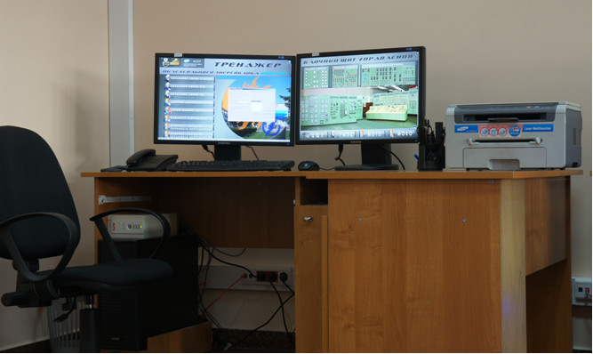
The simulator Plant Model ensures the modelling of unit technological equipment modes of operation, as well as its control systems: isolation and regulating valve’s control, modulating control, instrumentation, protections and interlocks, alarms, etc. The Plant model ensures also the modelling of electrical equipment control systems.
As example, it’s pointed out the volume of unit valves modelling:
- Control vales with electric power control, 130 items;
- Isolation valves with electric power control, 162 items;
- Manual isolation and regulating valves, 921 items.
It is worth to point out that a lot of operations during unit start-up is performed by field operators. It is also estimated that a lot of mistakes at real technological equipment are made by field operators. That is why, great importance during the simulator design was dedicated to creation of field operator’s work place. As example, the following displays can be pointed out:

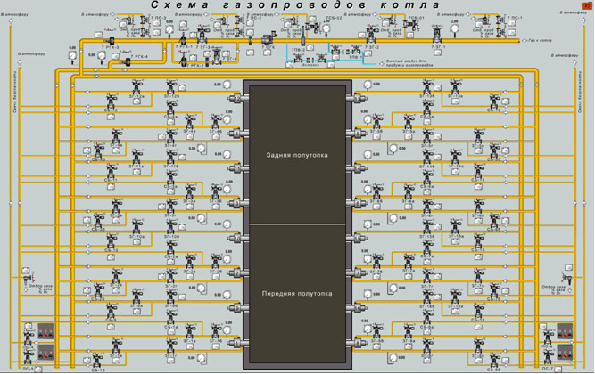
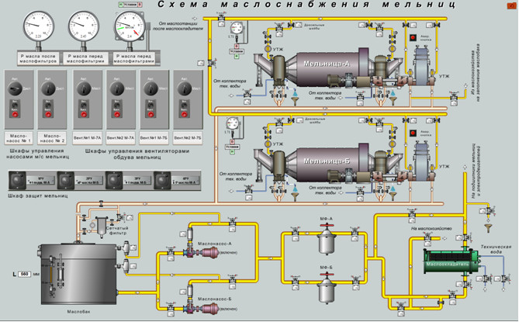

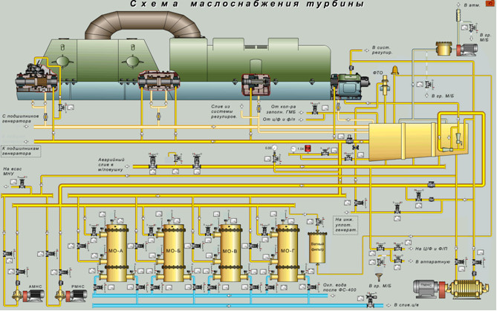
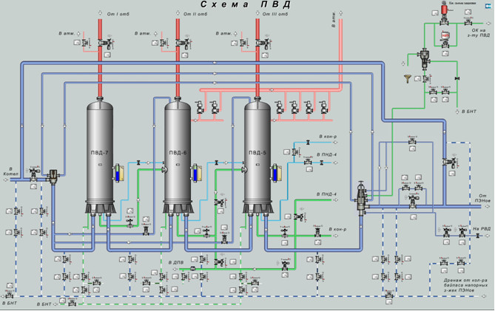

As example of on-duty electrician (electrical department) work place, the following displays can be pointed:

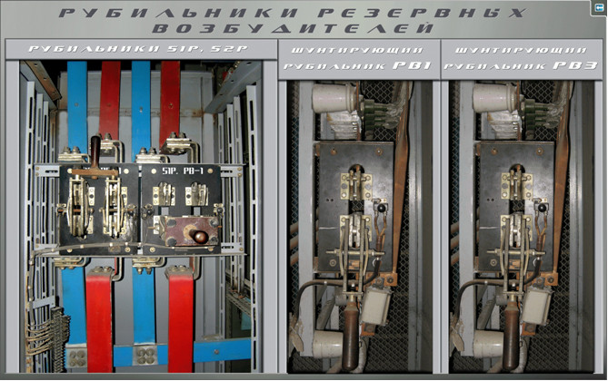
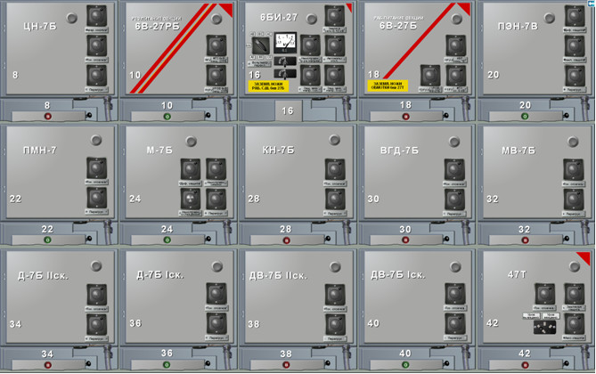
On displays of control room operator all control panels and consoles are depicted. All instrumentation and control elements are depicted on each console and panel (keys, switches, alarm and protection indicators, regulator’s manual/auto stations, etc.). All should be adequate, including inscriptions, to real equipment. The trainee interface with simulator is ensued by «mouse” manipulator.
On field operator work places, besides local control panels and consoles, technological diagrams and equipment fragments are depicted. Field operator can change regulating and isolation valve positions on this displays (manual or electric power operated). Field operator can monitor the technological process by locally installed instrumentation depicted on displays: manometers, level measuring devices, position indicators, etc.
Very simple and convenient simulator interface (includes 118 displays) gives the opportunity to switch from one display to another very quickly and conveniently:
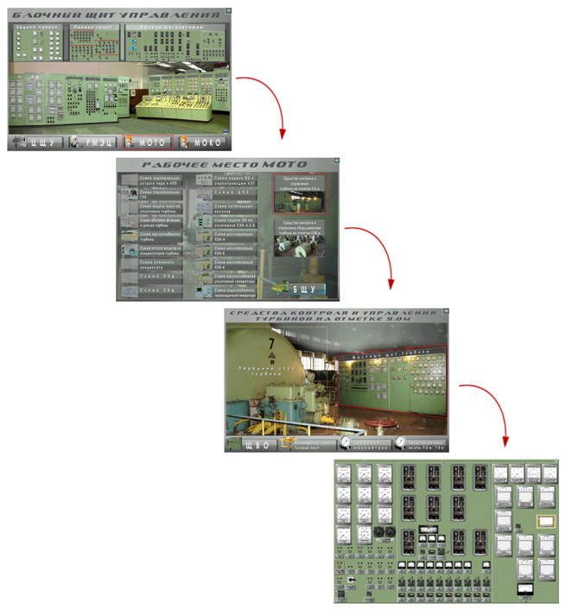
CAD principles of the simulator development tools simplifies the simulator design process and gives to designer-technologists means of efficient and quick Plant Model correction.
Development tools consist of:
- MnemoCAD;
- TechnoCAD;
- AlgoCAD.
MnemoCAD is used as computer aided tool for simulator dynamic displays creation.
TechnoCAD is a CAD tool for technological equipment mathematical model development and testing. TechnoCAD allows to create mathematical models of hydraulic and aerodynamic systems from which unit technology consists, and also thermodynamic processes. Object-oriented model development in TechnoCAD gives the opportunity to present a model in the form of formal structure that consists of nods and elements, which are connected between themselves:

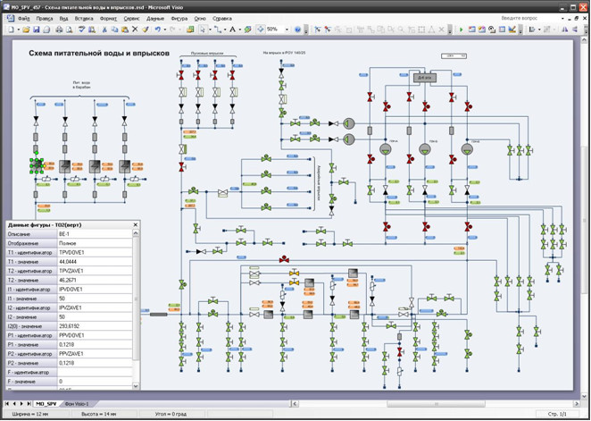

The Model of unit control systems and control systems of electrical equipment is developed by AlgoCAD tool. The Model is developed as set of function block diagrams on the basis of real control systems documentation and diagrams. The Model project consists of algorithm pages that are structured in directories:



