Complex computer based simulator

of 300 megawatt unit with TPP-312 TKZ pulverized coal steam generator,
K-300-240-2 turbine and TGV-300 generator

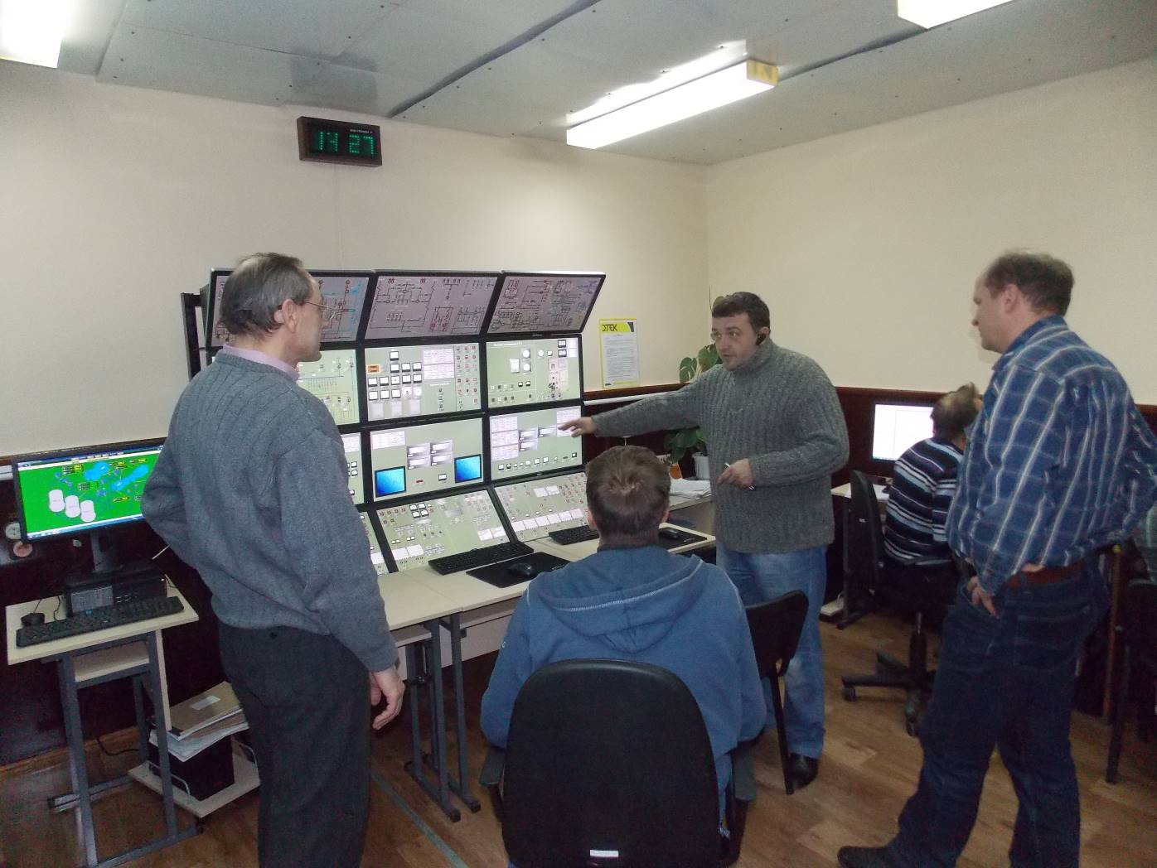

Lviv, Ukraine
“EMV ENERGO” designed the training simulator for Ladyzhin Fossil Fuel Power Plant Training Center. The simulator is intended to use for shift operating personnel learning and training. As prototype unit the Customer chose the unit №1 of the Plant.

1. The simulator’s task
The simulator should ensure the process of learning and training of power unit shift operating personnel.
Due to the fact, that in real unit equipment a lot of procedures (especially during unit start-up and shut-down, technological equipment switch over) are performed by field operators, very great importance was paid to field operator’s work places development. The fact is also that this category of personnel is, as a rule, less qualified and makes more mistakes.
With the purpose of field operator work places development, all manual isolation and regulating valves were also included in the Plant Model of the Simulator. Also, manual draining and blow-down valves were included to the Model to imitate field operator’s activity. At the prototype unit of the Simulator there are 1053 items of manual valves, but only 296 items of electric power operated isolation and control valves. At this example, it is clear that at Ukrainian power plants number of manual valves exceeds more than three times power operated ones.
With the purpose of shift operating personnel training, the Simulator includes the following work places:
- Instructor work place (Instructor Station);
- Boiler and turbine department shift supervisor work place;
- Unit control room operator work place;
- Unit control room senior operator work place;
- Turbine equipment field operator work place;
- Boiler equipment field operator work place;
- Senior on duty electrician work place;
- On duty I&C department electrical fitter work place (in accordance with the Customer demand).
The training simulator structure is shown at the picture below, where:
РМ Інстр. – Instructor work place (Instructor Station);
РМ МЕБ – Unit control room operator work place;
РМ МОКУ - Boiler equipment field operator work place;
РМ МОТУ – Turbine equipment field operator work place;
РМ Ел.Ц – Senior on duty electrician work place.

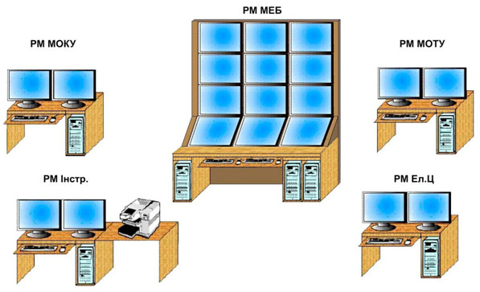

2. Conception
2.1. Work places
2.1.1. Work place of unit shift supervisor, control room operator and senior control room operator should imitate interface of the Unit Control Room. For this purpose, the place is furnished with sufficient quantity of monitors. The picture at fig.2 shows the work place with 12 monitors that ensures the simultaneous view almost of all control room panels, desks and consoles with exception of the side panels and not operative rear panels. At the display frames all fragments of control room are depicted: panels, desks and consoles with mimic diagrams, instrumentation, switches, knobs and keys etc. (fig. 3, 4, 5). During the simulator design stage the amount of monitors for this work place should be chosen, and in the first place, the convenience should be taken into consideration: most possible number of panels, desks and consoles should be in the operator’s view simultaneously. But, if necessary, any display frame can be summoned at each monitor (for example side or rear panel) with the help of control room display frame-menu (see fig.1)
2.1.2. Field operator’s work places
Special attention should be paid for the development of boiler and turbine field operator’s work places. As it was already mentioned, a lot of operations, especially during unit start-up and shutdown, are performed by field operators at technological equipment.
Turbine and boiler field operator’s work places are realized at office computers with two monitors. The example is shown at fig. 6. At this work place displays the technological diagrams are depicted with all manual and electric power driven isolation and regulating valves, as well as instrumentation, installed at technological equipment (manometers, glass level indicators in vessels, glass windows for turbine bearing oil monitoring, etc.), local panels and desks, knobs that are installed near mechanisms for their emergency switch off.
Field operators during training process have possibility to change position of manual valves and also, controlled from the Unit Control Room. It is possible also for field operators to monitor the technological process by locally installed instrumentation and dynamic pictures, imitating and depicting technological process, which field operators see at the object, for example: flame of burners, stream of blowdown water, oil to turbine bearing etc. Example of boiler field operator’s display frame is shown at fig.7.
2.1.3. On-duty electrician work place, like turbine and boiler field operator’s, is organized at office computers. There are panels, desks of electric equipment control at the display frames (Unit Control Room), and also locally installed means of monitoring, control and signalization of electric equipment: local control cabinets, cells of KRU 6 Kv, RZA panels (relay protection and automation), panels of main and reserve generator excitation, instrumentation etc. Examples of display frames are shown at fig.8, 9.
2.1.4. On duty I&C department electrical fitter work place
This work place should be developed during the Simulator design, if demanded by the Customer. The volume of modelling should be discussed and specified, as the training tasks also.
All control system diagrams of the unit are modelled in the Plant Model. At rear panels all switches, keys, knobs, lights etc. of signalization, interlocks and protections are depicted and animated.
2.1.5. Instructor Station
The Instructor Station allows to start the Simulator with specified unit initial state, for example: cold start, hot start, cold turbine – turbine on turning gear, hot turbine – ready for synchronization, half load, full load etc. The Station ensures instructor with means of organizing the training process: to insert disturbances during training (technological and in control systems), to monitor trainee’s activity. It is also possible to create different scenarios before training session and use these in training process.
2.2. Unit Plant Model
The unit technological systems Model adequately represents the main and auxiliary equipment operation in unit start-up, loading and nominal power mode of work. The Plant Model consists of separate sub-model set. Each of the sub-models represent operation of one of technological systems. All sub-models interface through on-line database.
The Control System sub-models represent the operation of the unit Control Systems: algorithms of pumps and fans control, electric switches, isolation and regulating valve control, protections, interlocks, signalization and alarms, regulators, logic control etc. The Control System sub-models development is made on the basis of electrical diagrams of I&C department, electrical department, their technical documentation: manuals and descriptions, alarm and protection setpoint documentation etc.
The Plant Model is installed at the computer of Instructor Station.
3. The specific of Training Simulator realization for unit with Digital Control System
The specific Training Simulator, described in this document was developed for the unit with not Digital Control System. With time, the unit equipment will be modernized, the old Control System will be replaced by the Digital one. So, during the Simulator exploitation the Simulator also should be modernized.
Work place of unit shift supervisor, control room operator and senior control room operator should imitate interface of the Unit Control Room (as it was pointed already). In the case of Digital Control System, the hardware and software technical means of upper level should be used: operator’s stations, information monitors, panels etc. With the purpose of savings, it’s possible to use less amount of operator’s stations and information monitors: the necessary quantity is discussed with the Customer. It’s possible also to use at training simulator cheap office computers instead of expensive real ones. But the quantity and quality of information received by trainees at the simulator should be sufficient and not to distort the training process, especially during unit start-up and emergency situation simulation. All this issues should be discussed with the Customer and decision should be made.
Virtual Controllers application makes it possible to use at the simulator the algorithms of the real digital control system. A virtual controller as a rule is organized at office computer (with control system algorithms installed). Virtual Controller application also simplifies the process of simulator correction in case of control system algorithms correction or modernization during unit exploitation. It’s worth to point out that almost all advanced Companies – developers of digital control systems have efficient software means for virtual controllers creation.
It should be pointed out that unit modernization with control system replacement for the digital one, nevertheless leaves some technological operations to be performed by field operators. That is why field operator’s work places should be modernized but preserved at training simulator.
As example at fig. 10 is shown a structure of training simulator for unit with digital control system.
Application at unit simulator of real interface: operator–operator’s workstations, on-line database and algorithms of digital control system significantly enhance the quality of training process at such simulator.

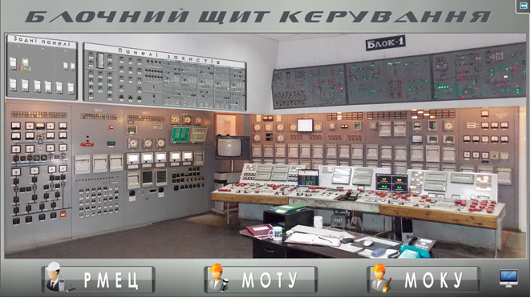
Fig.1 Display frame-menu of unit control room

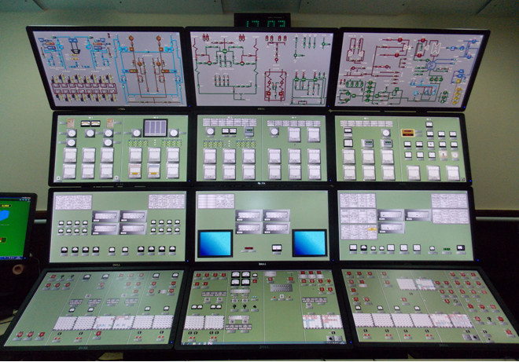
Fig.2 Work place of unit control room operator

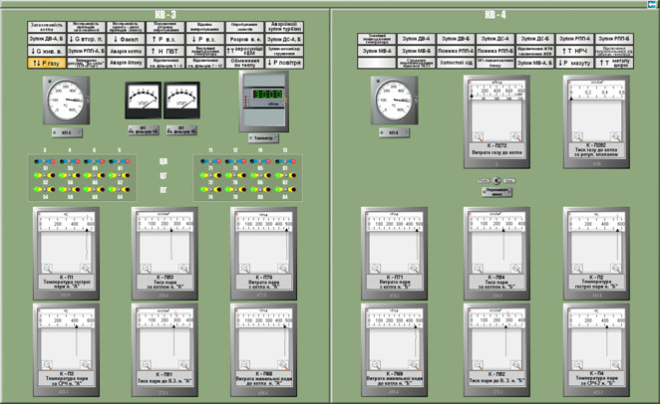
Fig.3 Display frame of unit control room panel

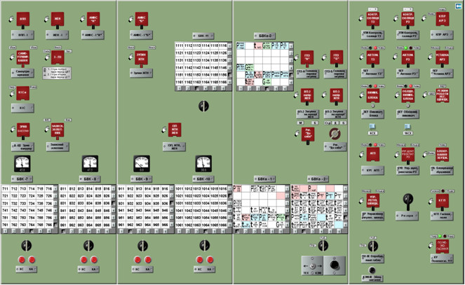
Fig.4 Display frame of unit control room desk

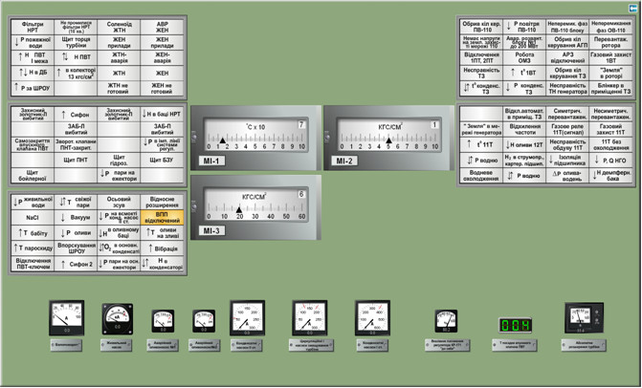
Fig.5 Display frame of unit control room console

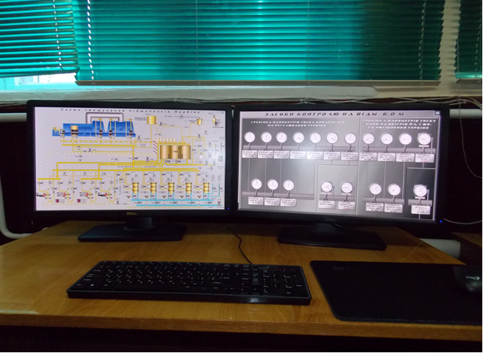
Fig.6 Picture of turbine field operator’s work place

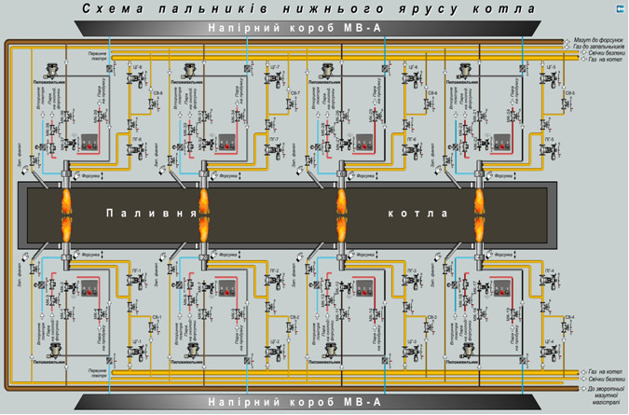
Fig.7 Example of boiler field operator’s display frame

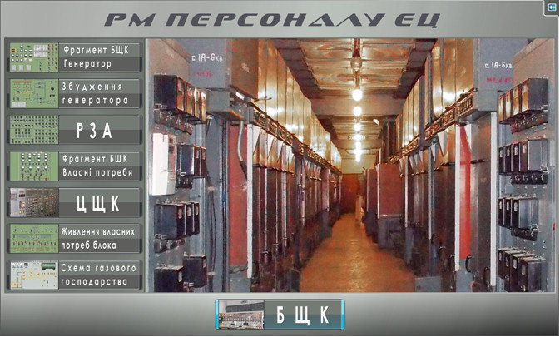
Fig.8 Display frame-menu of senior on-duty electrician work place

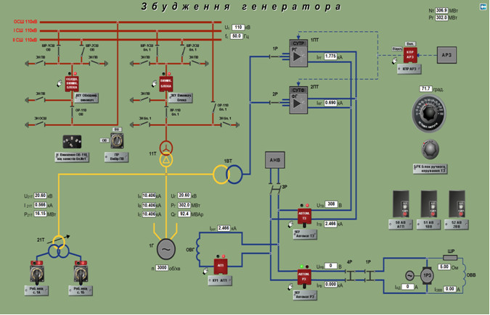
Fig.9 Display frame of senior on-duty electrician work place. Turbine generator excitation

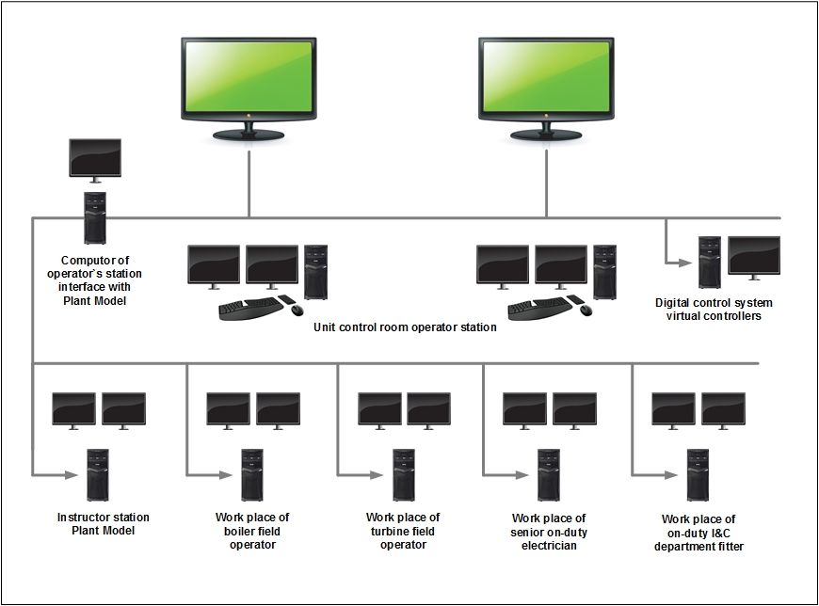

Fig.10 Specific of traning simulator for unit with digital control system

